

**Risk Explorer for Software Supply Chains Project**

**README File**

Aljawhrah A. Almalhim , Cady A. Alnafea

7.1 Setup Documentation

• Prerequisites:

* JavaScript, HTML, CSS
* Node.js

• Installation Instructions:

Before running the project, make sure you have Node.js and npm installed (this sample is for MacOS):

1. Install the HomeBrew using this command “/bin/bash -c "$(curl -fsSL <https://raw.githubusercontent.com/Homebrew/install/HEAD/install.sh>)"
2. Then run “brew install node” to install Node.js
3. To verify that both node and npm are installed using these commands “npm -v” & “node -v”, this will show the version
4. Open GitHub on the following link: <https://github.com/SAP/risk-explorer-for-software-supply-chains/tree/main?tab=readme-ov-file>
5. Download the code ZIP file

• Execution Steps:

1. Open the terminal and write the command “ls”
2. Locate the downloaded folder “cd risk-explorer-for-software-supply-chains“
3. Run “npm install” to install all the dependencies listed in the package.json file
4. Now you are all ready to run the project using the command “npm start”

A new page in you local browser will open with the following link: http://localhost:3000/risk-explorer-for-software-supply-chains#/

• Troubleshooting:

During the step up, we faced an issue caused by not installing Node.js proberly, we followed the steps mention in the official Node.js website, however the error kept occuring, to resolve it we used the following command as mentioned above “brew install node”

• Screenshots:

After following the steps mentioned above, you should be prompt the following page in your terminal showcasing the local host that the project is running on, as follows:

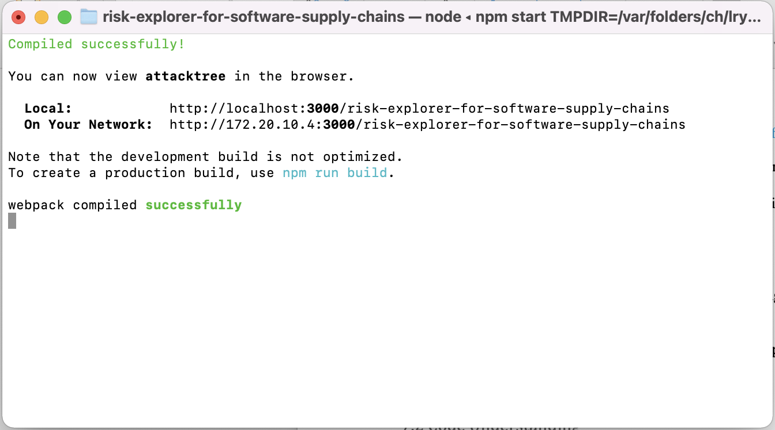

Then the project index page will open on the local browser, as follwos:

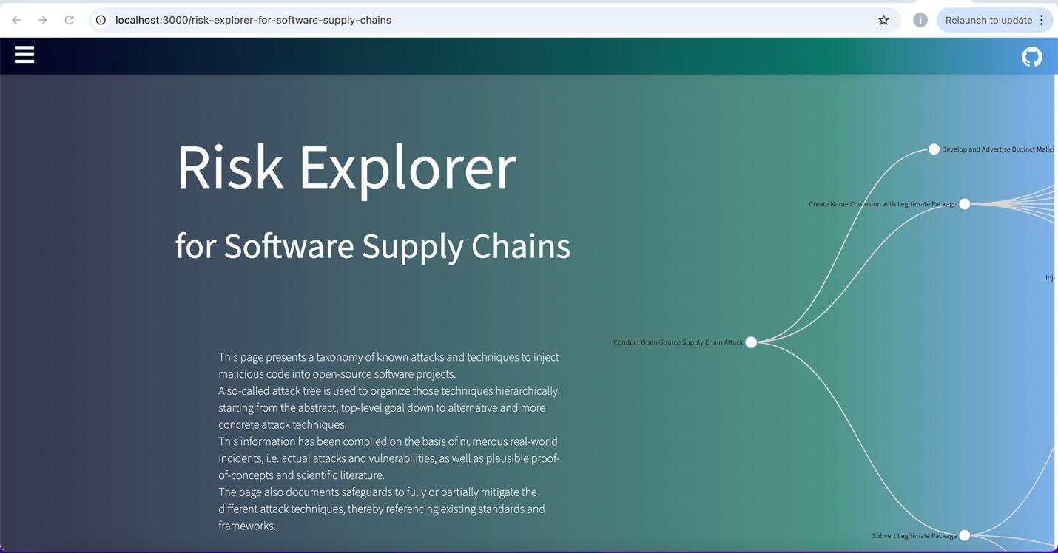

You can click on the menu botton to showcase all the available options:

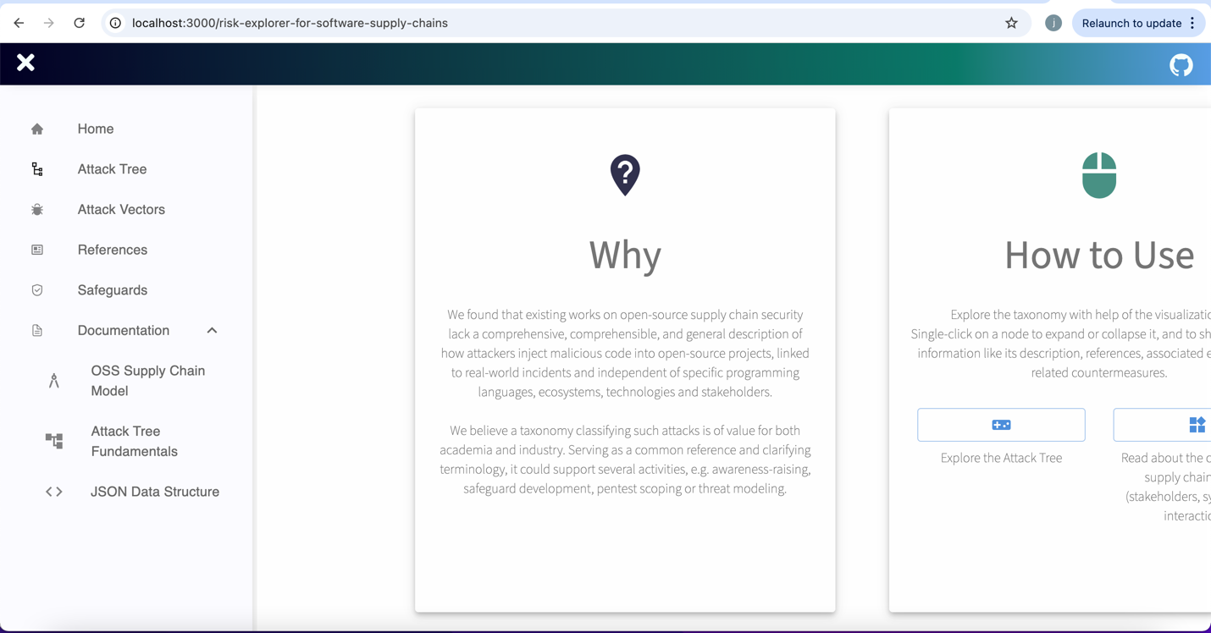

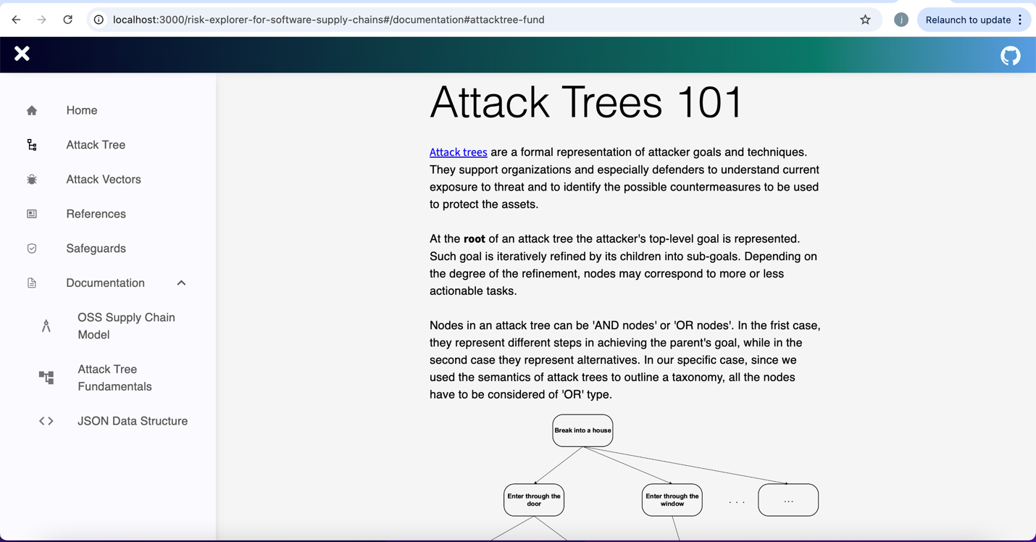

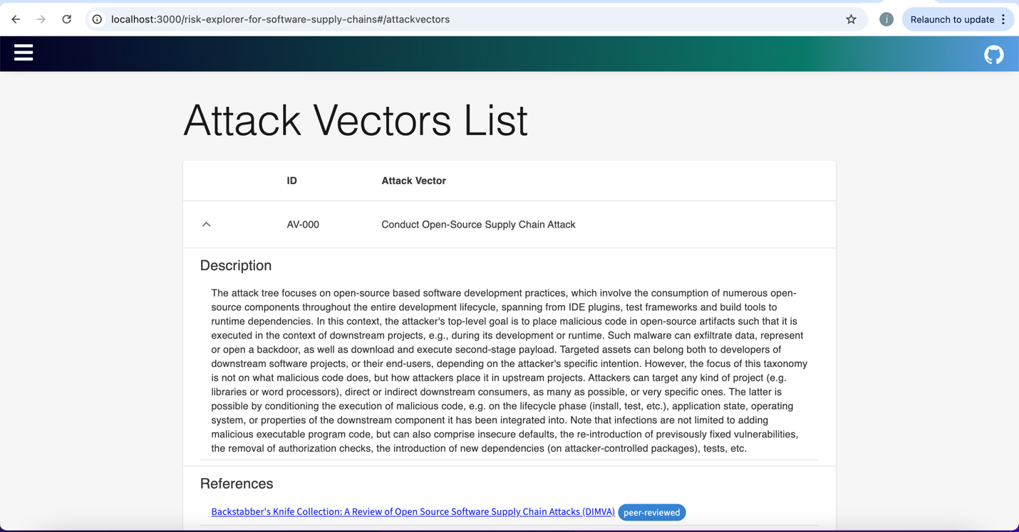

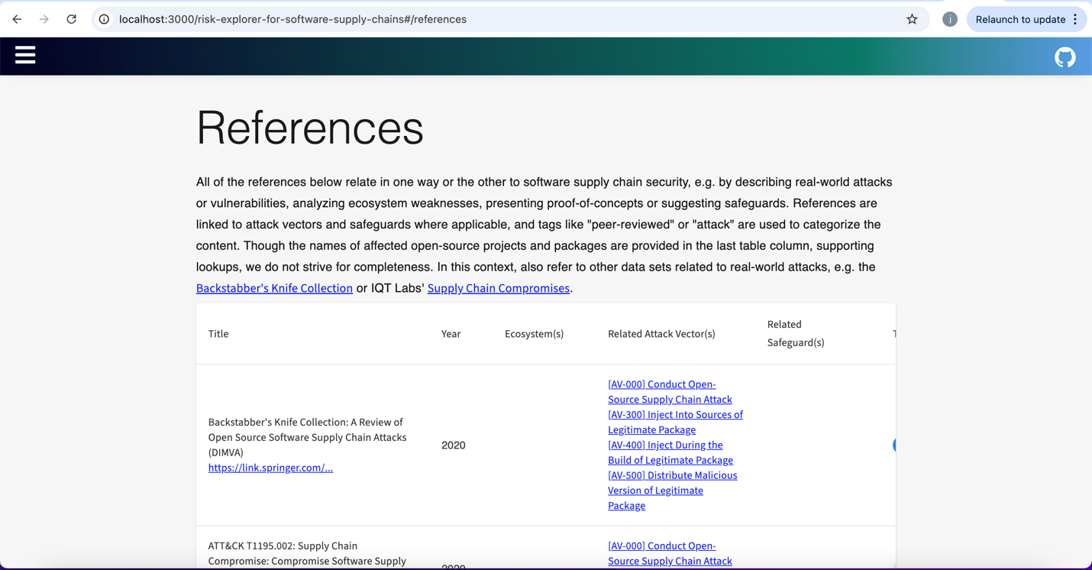

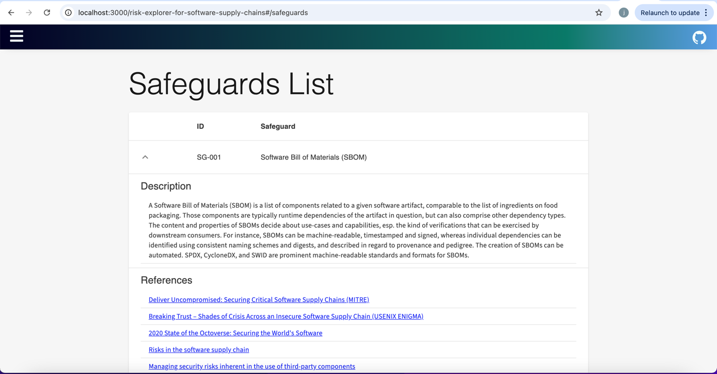

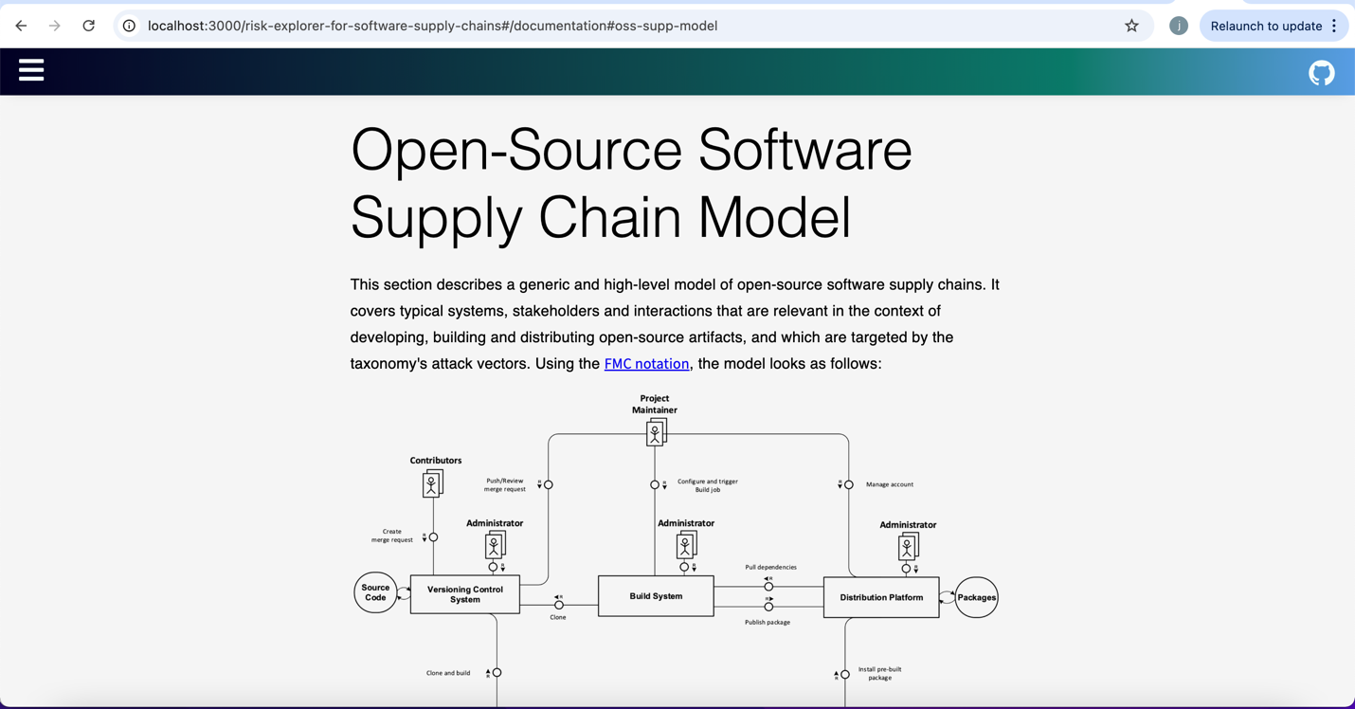

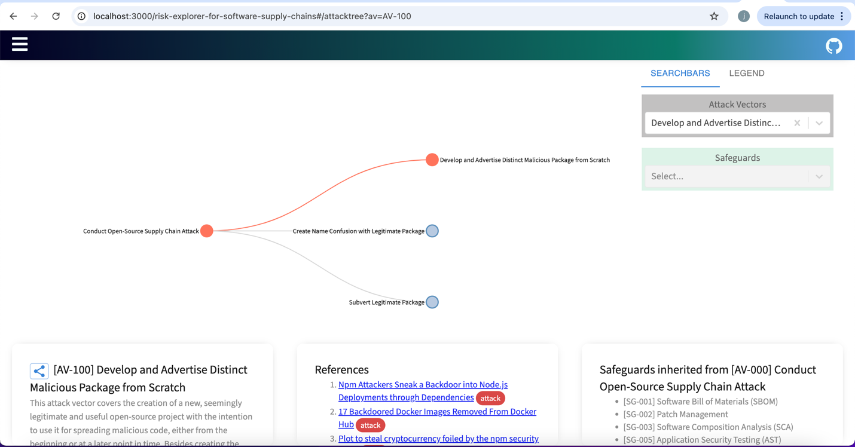

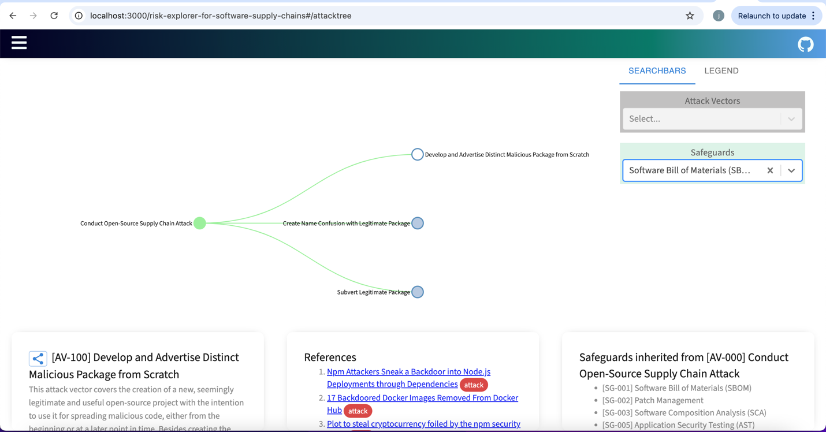

7.2 Code Understanding

• Annotated Code Walkthrough:

• Extensions or Insights:

App.js:

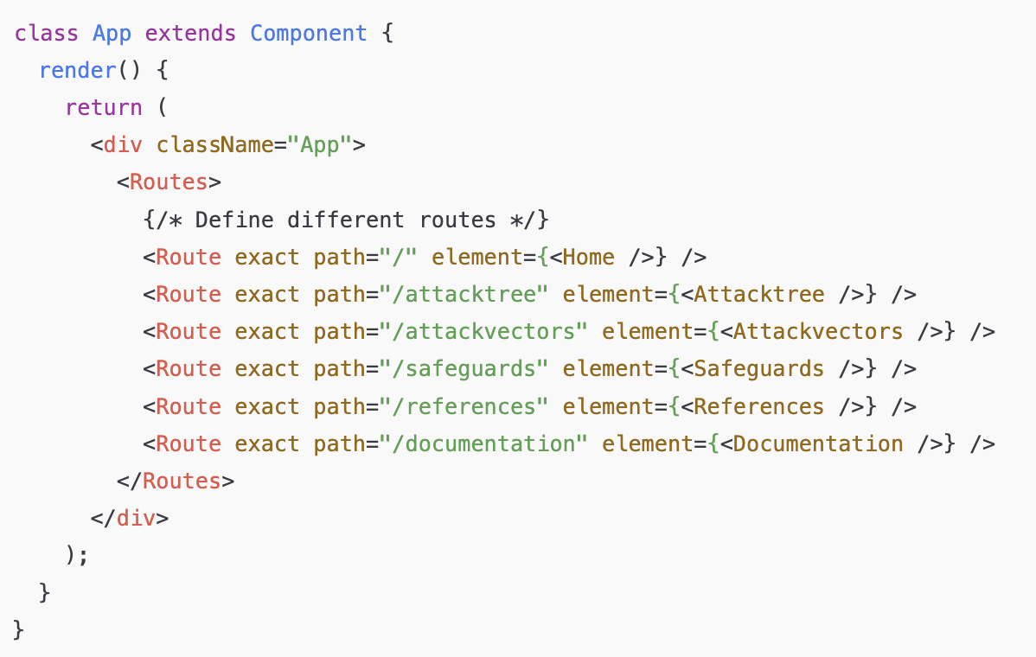

This code is used to render the pages and interct with the users clicks, by taking them to the designated location.

Home:

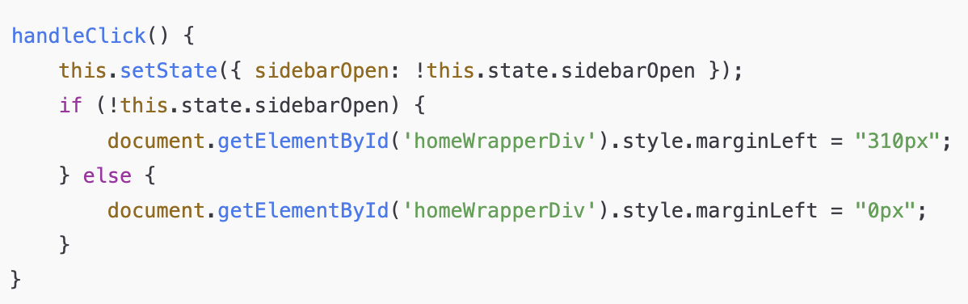

The purpose of this code is to render the main page of a web application that includes various interactive features, like a sidebar and buttons to navigate through different parts of the app.

AttackTree:

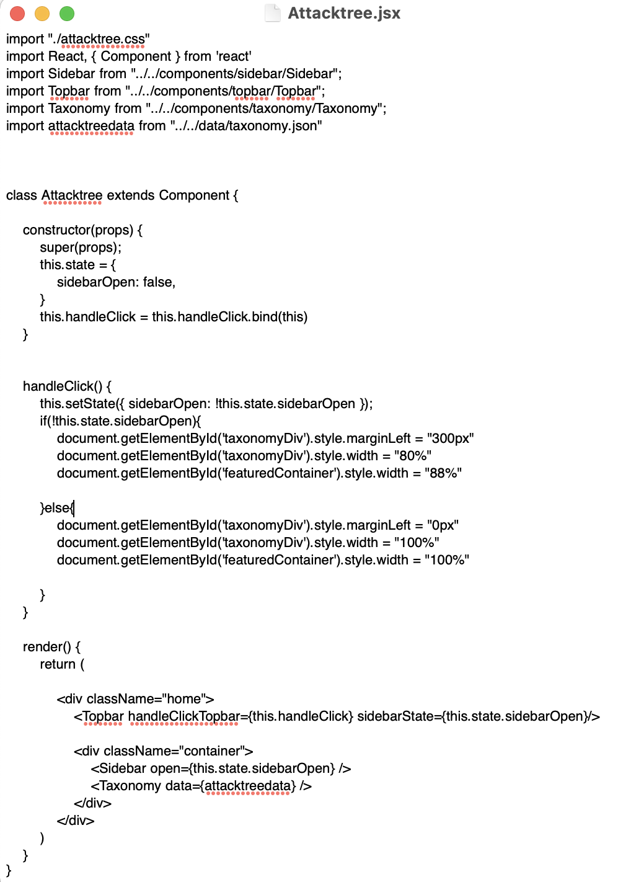

This code defines a **React class component** called Attacktree. It's responsible for rendering a page where users can interact with a sidebar and a taxonomy visualization (most likely a tree or hierarchical structure).

AttackVector:

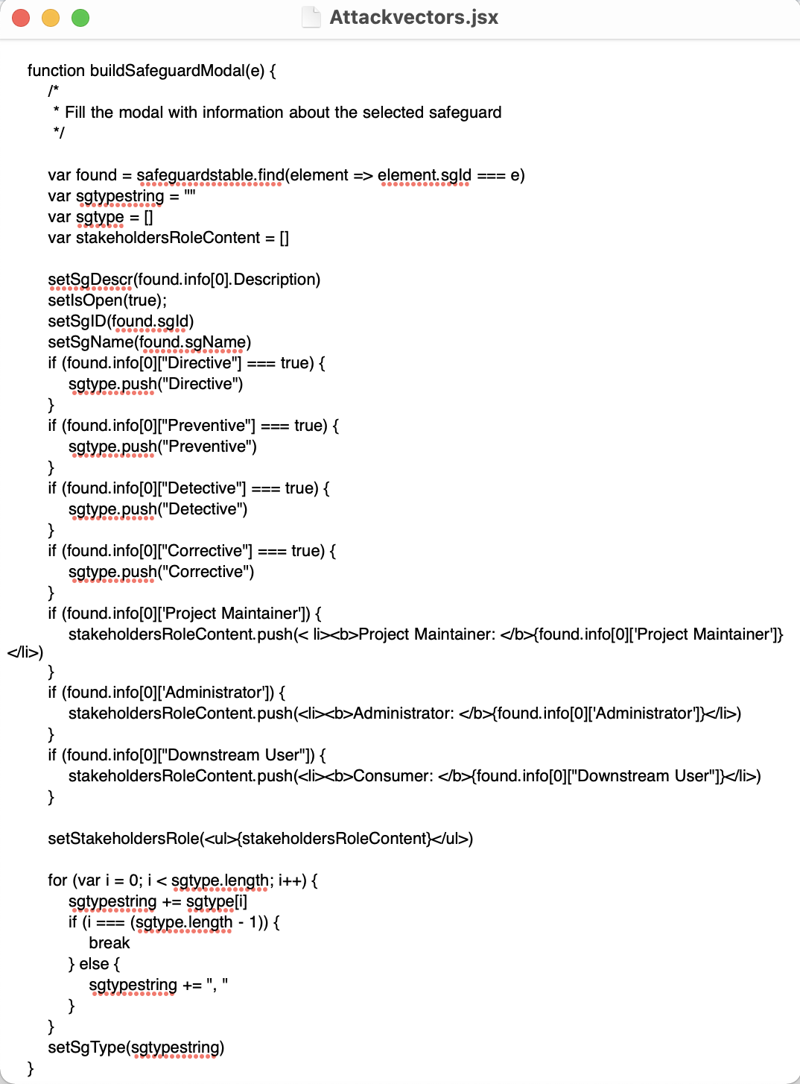

This code defines a React component called Attackvectors. This component shows a table of **attack vectors** (a concept related to cybersecurity, representing different ways an attacker might exploit a system). It also allows users to interact with the table to view additional information like descriptions, references, and safeguards associated with each attack vector.

Safeguards:

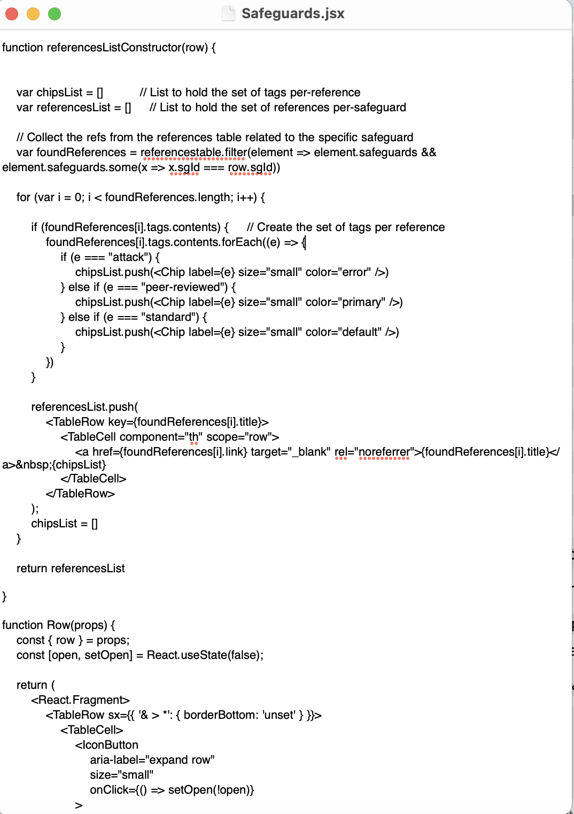

The purpose of the code is to create a user interface for displaying a **list of safeguards**. A **safeguard** refers to measures, actions, or tools implemented to protect against security threats or attacks. In this case, the list includes additional details about each safeguard, such as:

* **Description**: Explains what the safeguard is and how it works.
* **References**: Provides links to external resources related to the safeguard.
* **Control Type**: Categorizes the safeguard (e.g., Directive, Preventive, Detective, Corrective).
* **Stakeholder Role**: Shows the roles or responsibilities of individuals or groups (like project maintainers, administrators, or users) for that safeguard.

References:

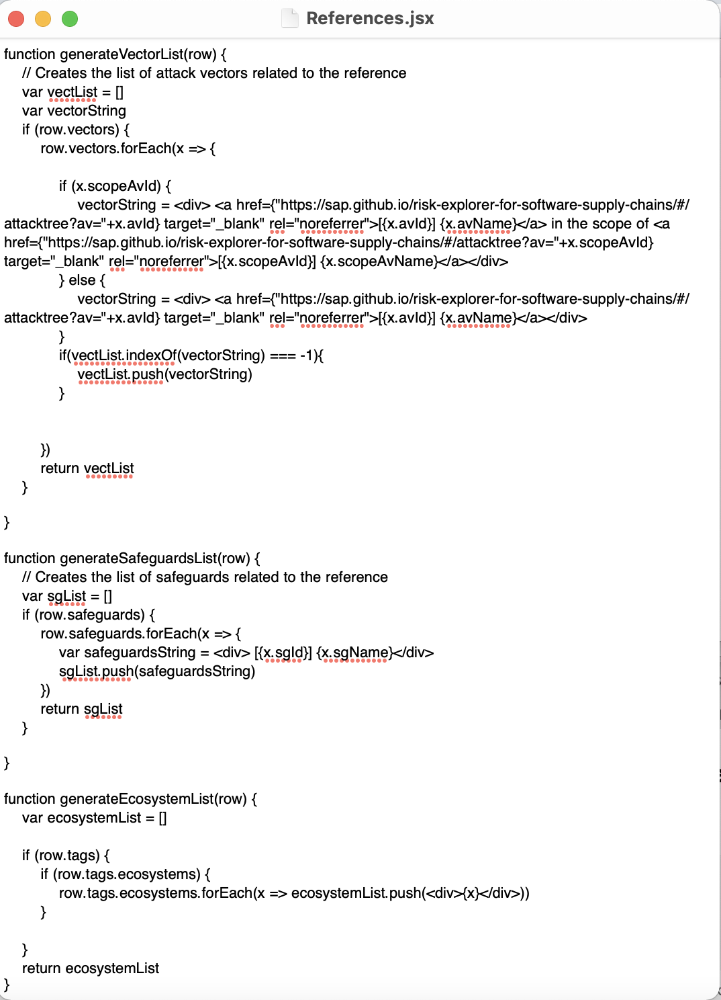

The main purpose of this component (References) is to present a table of references that are associated with different security aspects of software supply chains. Each reference may include details such as:

* **Title**
* **Year**
* **Ecosystems**
* **Related Attack Vectors**
* **Related Safeguards**
* **Tags** (e.g., "peer-reviewed", "attack")
* **Affected Packages** (which packages or projects are impacted)

Documentation:

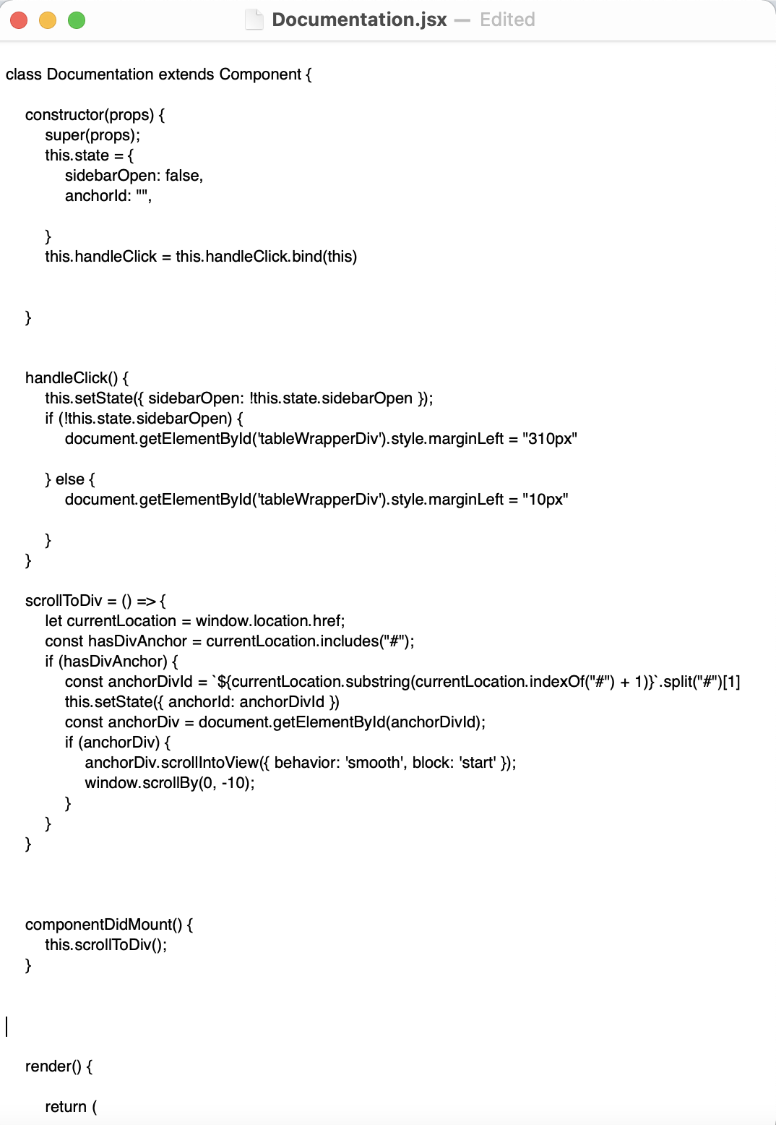

The Documentation component includes a sidebar that can be opened and closed using the handleClick method. The state sidebarOpen keeps track of whether the sidebar is open or closed. When toggling the sidebar, the component adjusts the layout of the main content area by changing the margin of the tableWrapperDiv.

– Proposed potential improvements, such as:

∗ Creating more interactive system to identify supply chain vulnerabilities.  
∗ Adding additional functionality to handle and improve performance.

• Current Flow Diagram:

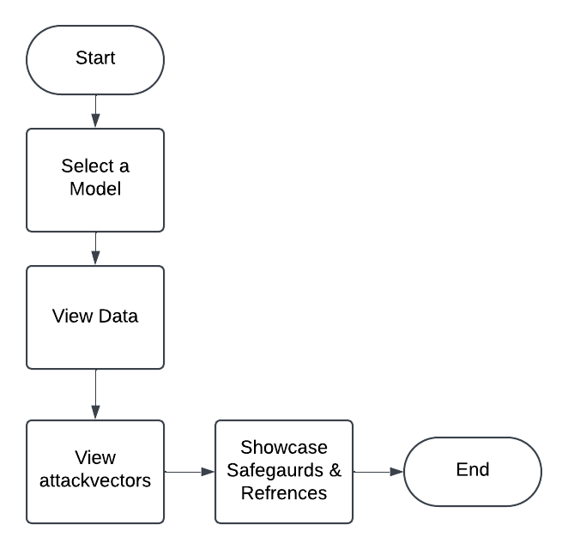

• Suggested Flow Diagram:

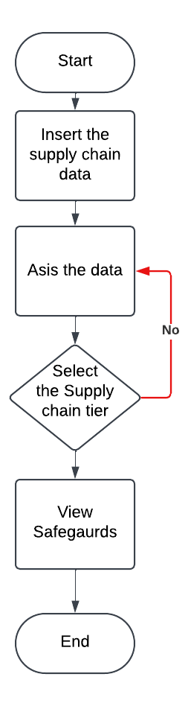

### 7.3 Input and Output Demonstrations

* **Input-Output Mapping:**

In the case of the selected paper, below sections will b explaining the user input/interactions if any

For the current scope, user interactions are kept to a minumun which is mainly to select the needed attack vector and present the linked refernces, safeguards and more detials explaining the attack vector history and background, it will be in selection from rather than manaual input and the main outputs are expected to be presneted to the user in the form of information pages.

Below are the main sections that have minmual interactions:

**Attacktree**: It basically will provide a visual representation of attack trees.

**Attackvectors**: Are the reactive buttons the user can select that would act in a way as the input to the proceeding outputs. Under it there is the ID as well as idenifed descrption field for this particluar component there is no external API calls for any external databases or lirbarares

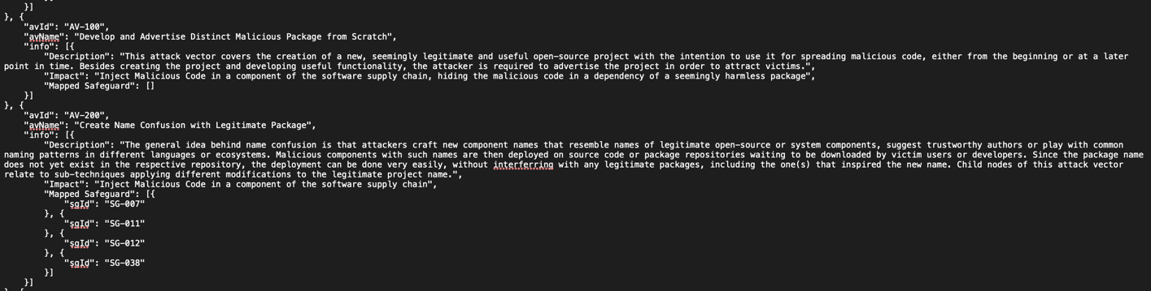

**References**: Once user select a certain attack vector , it will atomaticaly pouplate the output in a form of list for all realted refenrcnes scholary and grey realtied to the selected attack vector by the user, in this part as well there is no external API calls

below screenshot to showcase or give more in depth about how the links/refernces are stored as per the below 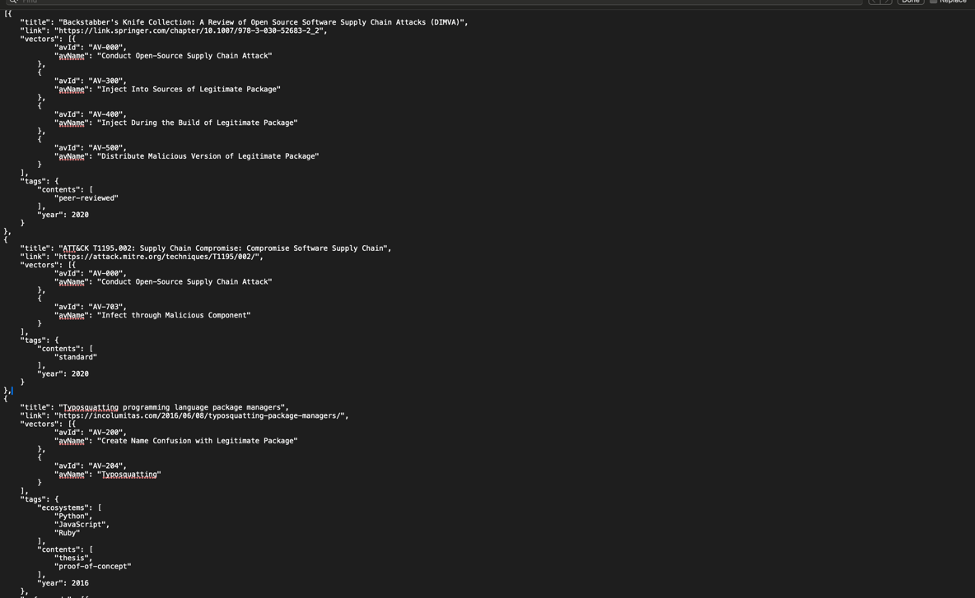

Moreover, output is shown by importing the refenrnces from reference.json file



**Safeguards**: Once user select a certain attack vector , it will atomaticaly pouplate the output in a form of a list of all realted safegurads with supporting reference from the below JSON file – detials showcased by the below screenshot.

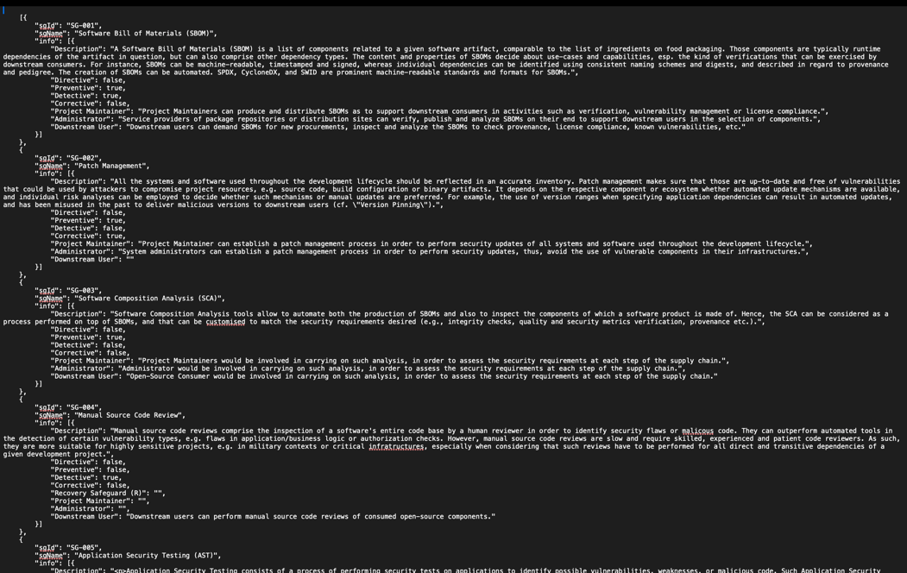

And its called by this function **“generateSafeguardsList()”** to produce the output which is the realted safegurad to the attack vector.

**• Test Cases:**

All other functionalites and information pages in the reported paper setup was poplaute

Testing the main ascept of the site which is the attack vector – in the below it has been tested from 2 areas from the attack vector page and the main page

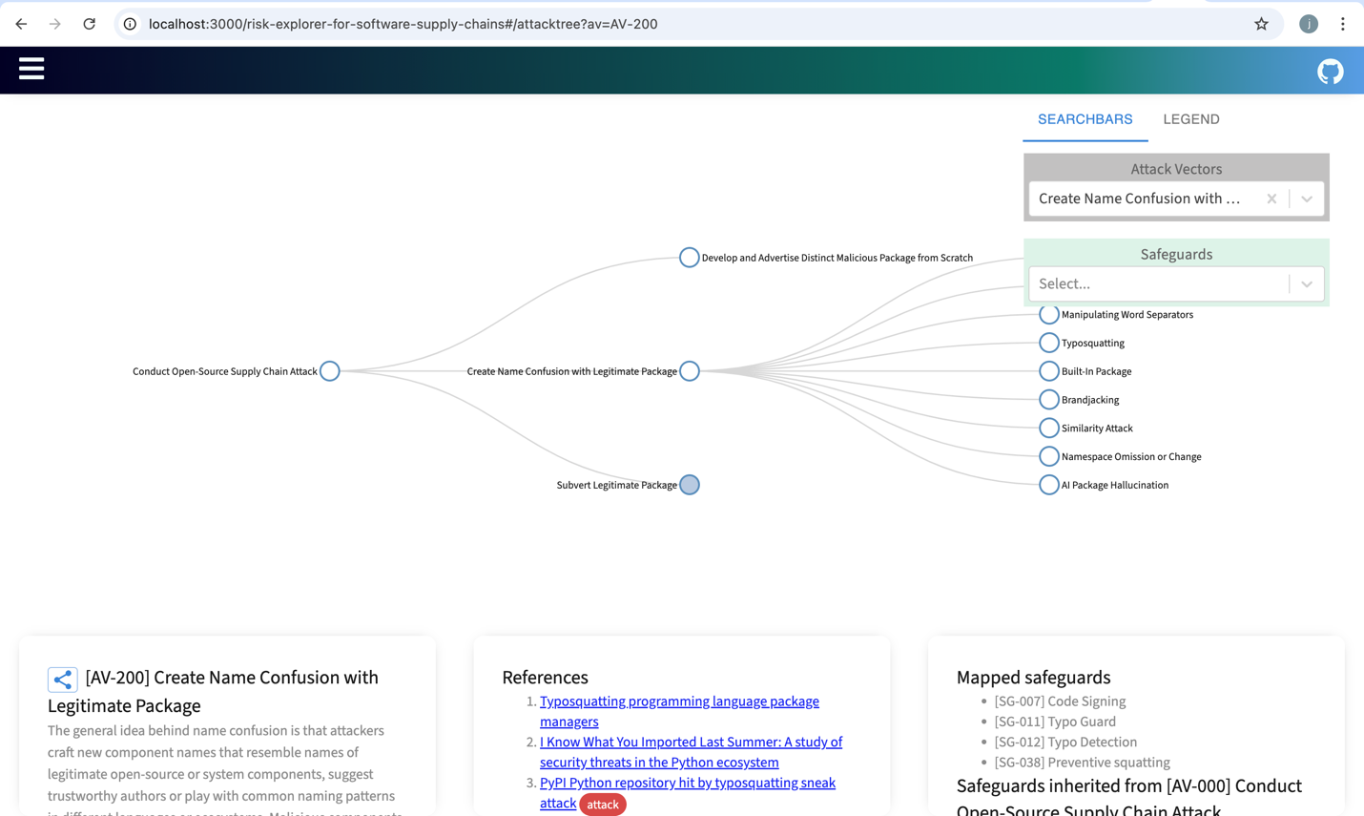

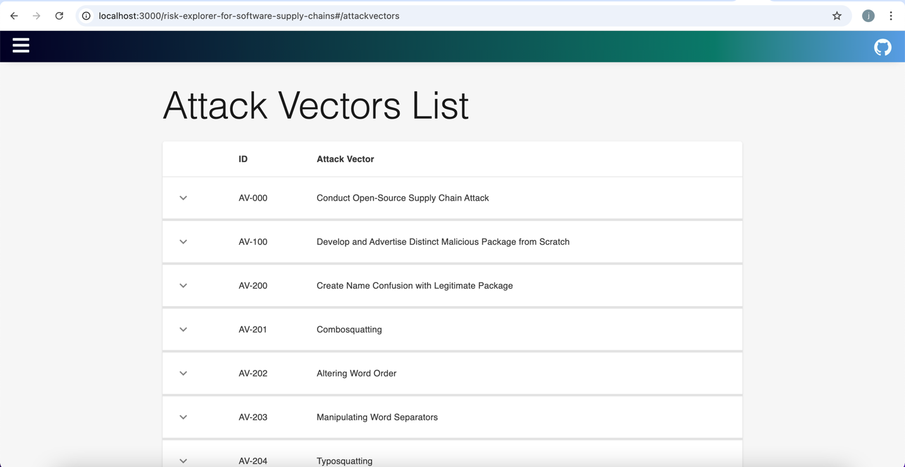

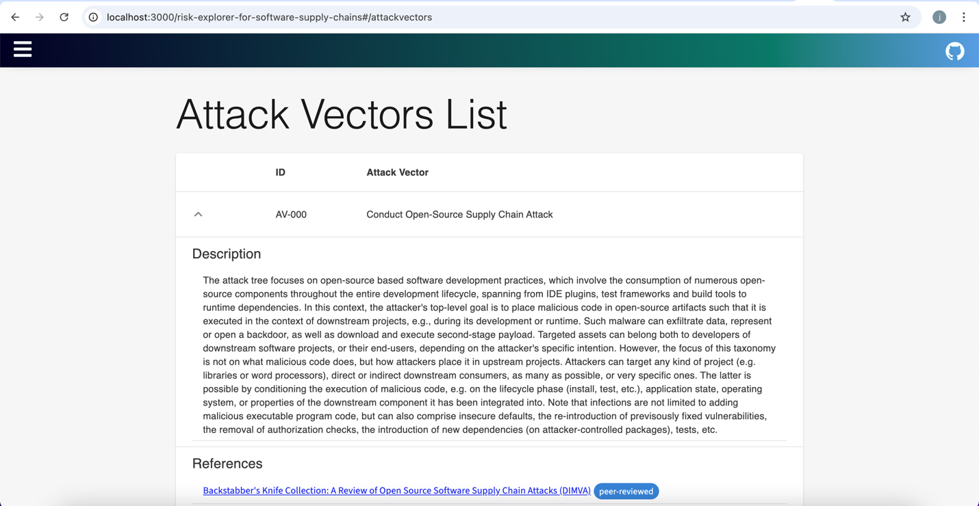

Then in the below screenshot we will be showcasing the doucmentation information page in the local setup

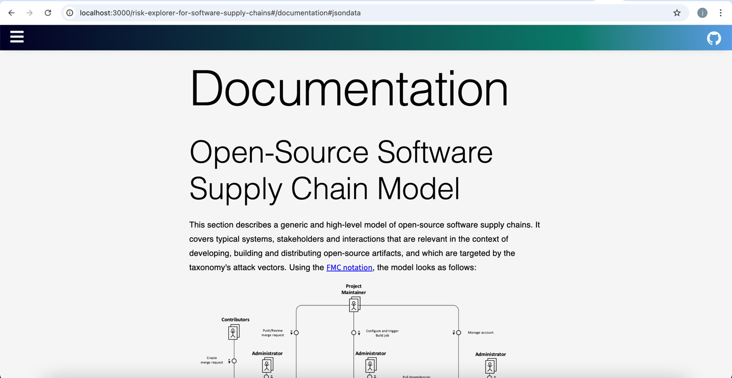

This screenshot will be mainly showcasing the orginal source where the refernces are being pulled from into the main page and we have tested all components they are working as expected.

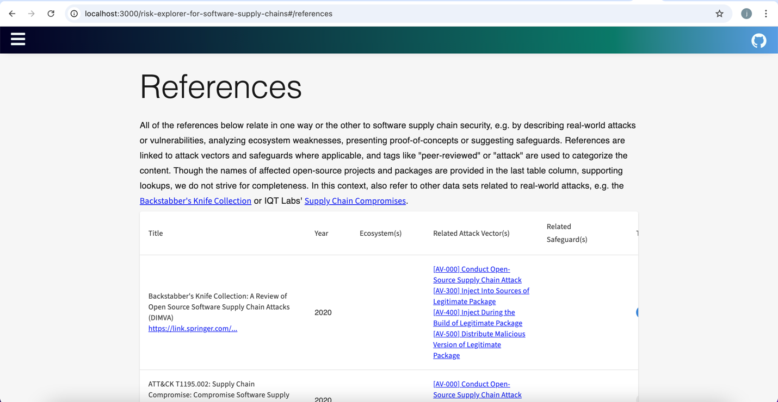

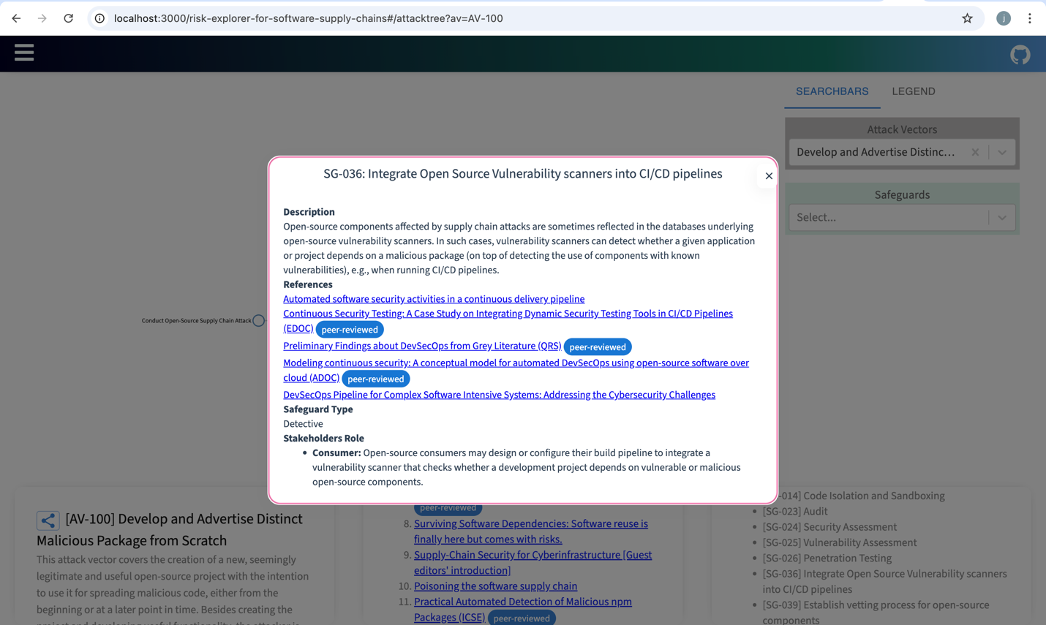

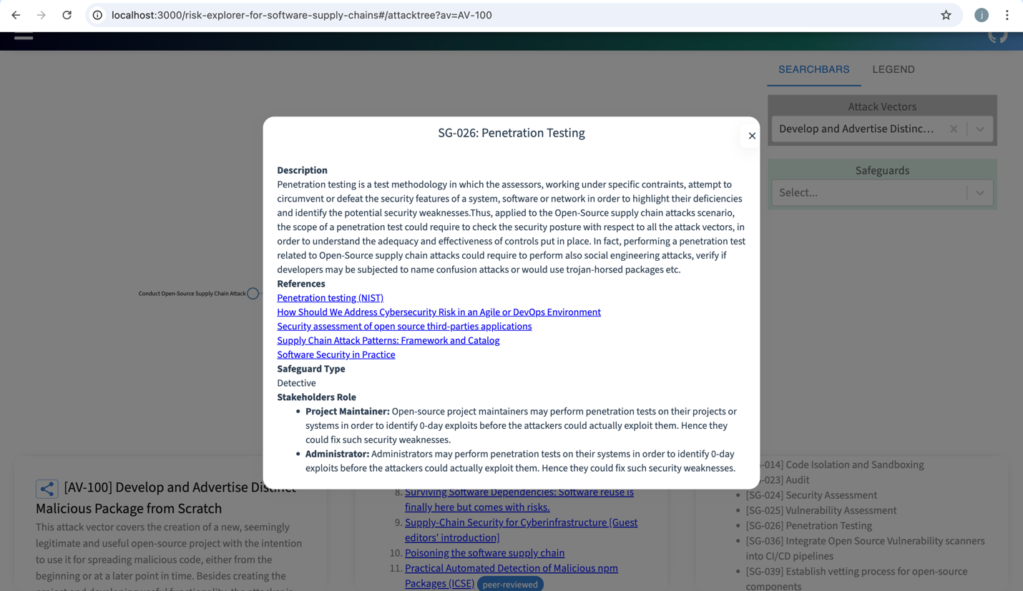

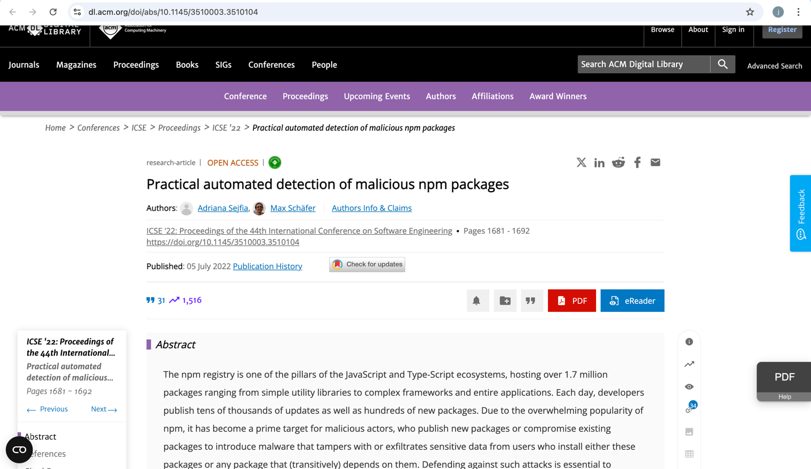

Same Navagation bar is present within local setup as well – showcased below

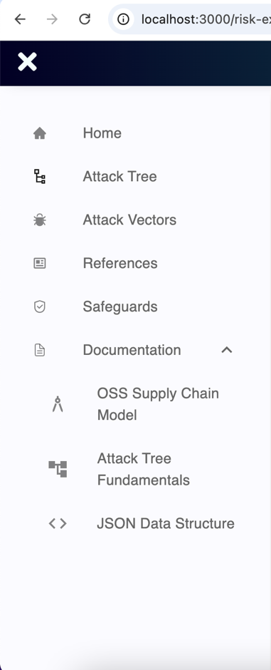



**• Comparative Analysis:**

There was no visblity of any discrepancies so far between setting up the code in our local enivorment and the posted site.

### 7.4 Validation

* **Key Metrics:**
* No detection is presented within this appaoch as its more about the correlation of mulitple input vectors to derive the approraite output based on user’s selection
* A validtion metric in the scope of the current work is to check the valdity of the reported attack vectors, safegurads and underlying refences since its mainly community efforts results might not be uptodate/reveleant to the current cirucmsnatances.
* **Reproduced Results:**
  + The reproduced and expected results are showing in the screenshoot below, which are same to what was reported in the paper. – Showcased in the below screenshots

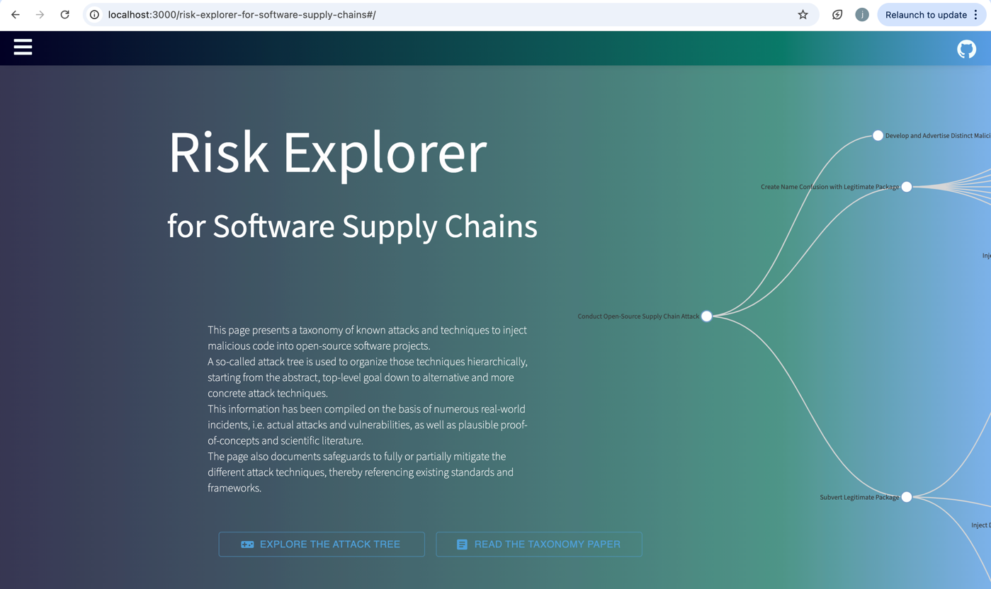(local host results)

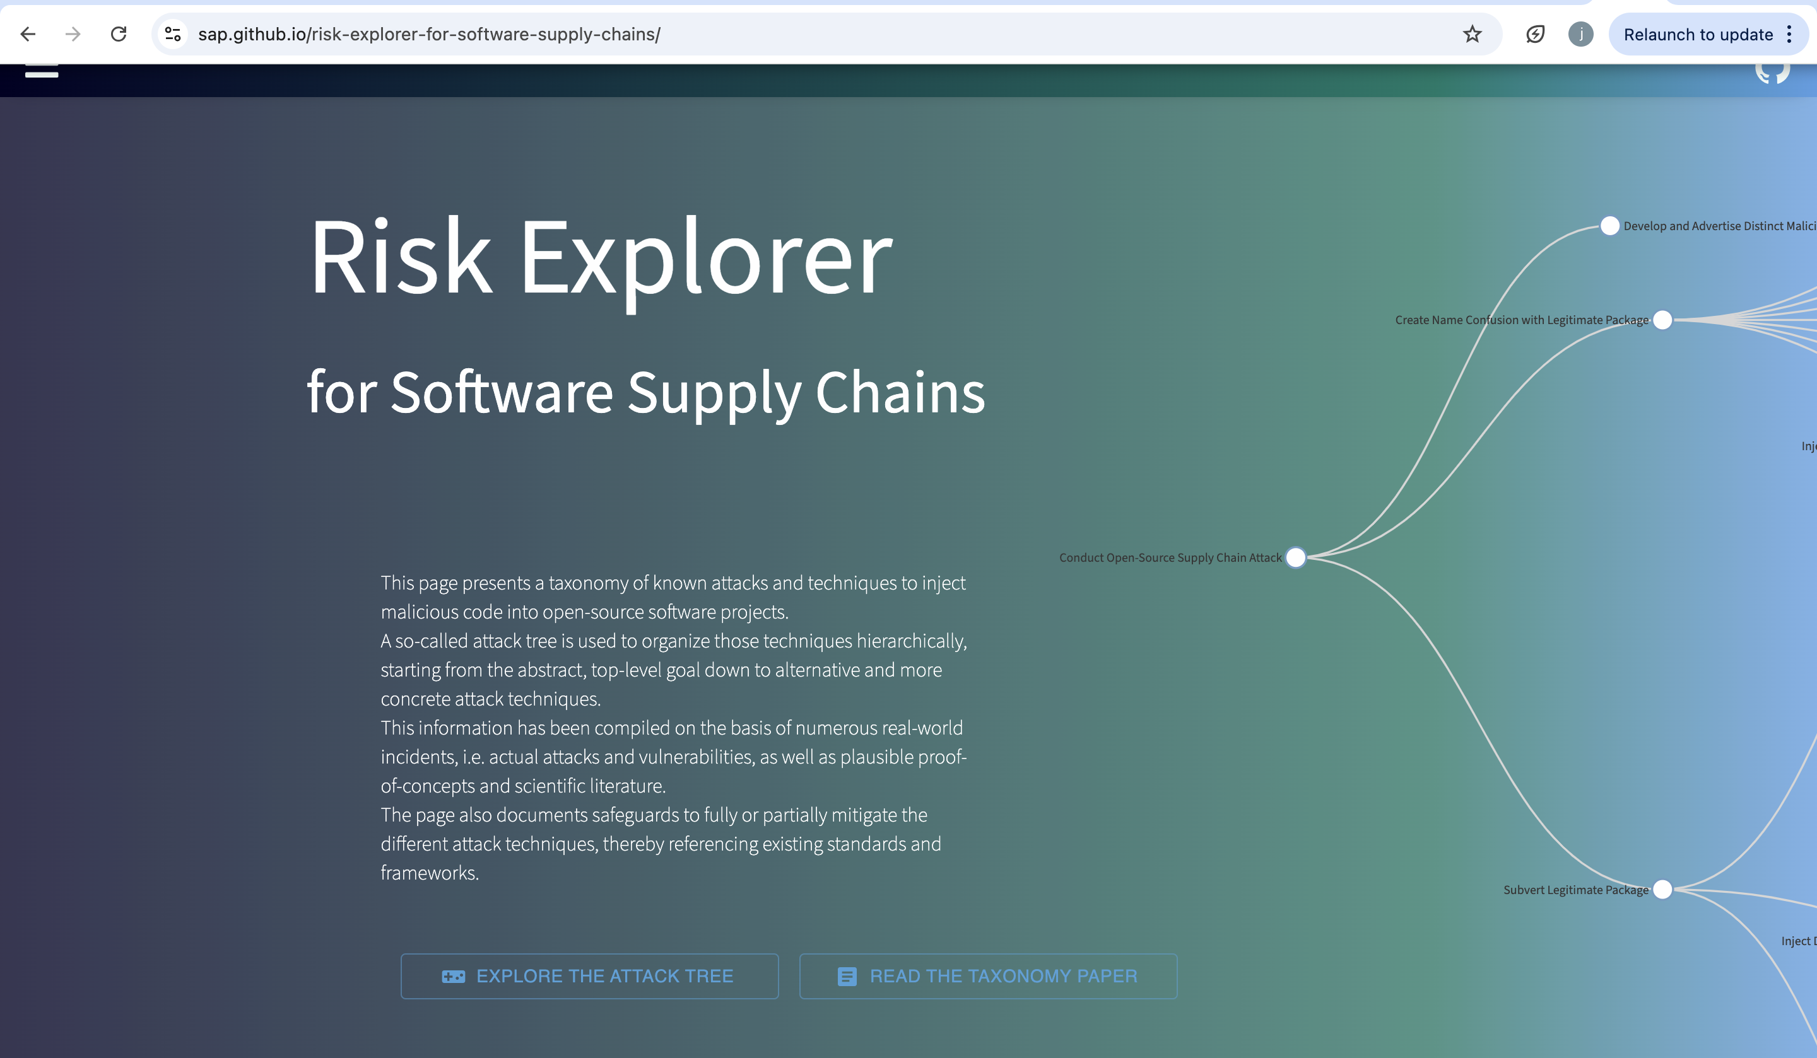

(reported paper setup)

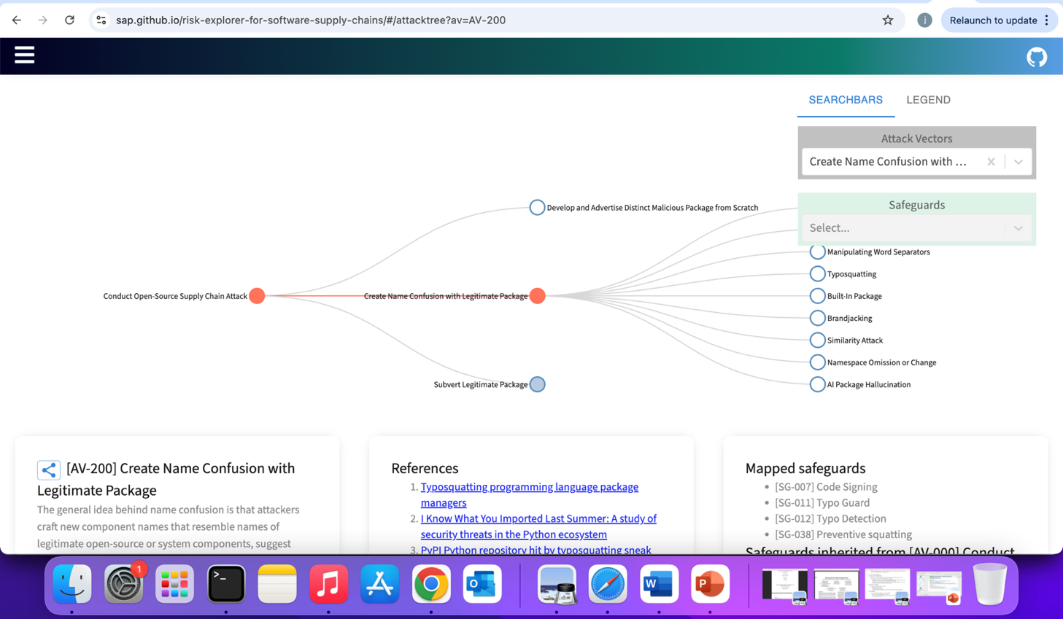

(local host results)

